Year 5 Hindu dharma
Year 5 Key Question (to be used all year): Where can we find guidance about how to live our lives?
Focus Question (for this investigation): What might Hindus learn from stories about Krishna?

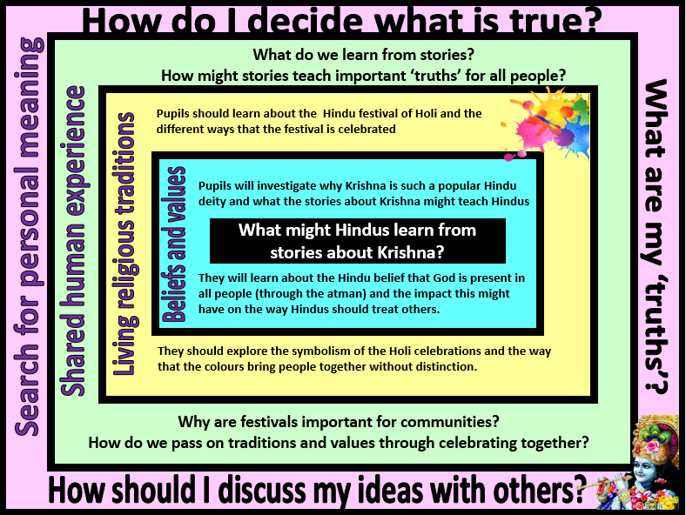
Focus Question: What might Hindus learn from stories about Krishna?
This unit enables pupils to examine how Hindu truths are transmitted using stories from revered literature. The focus includes beliefs about Brahman, Vishnu, Avatar (especially Krishna) and Scriptures. Opportunities are provided for pupils to explore some forms of Hindu literature and the beliefs and practices associated with a key story.
Pupils will need to revisit prior learning – in order to understand this unit, they need to know that Hindus believe in one God in many forms (Brahman) and that Vishnu is a popular form of Brahman as he is seen as the protector and preserver. One way that Vishnu fulfils this role is through avatars. They will already be aware of one of Vishnu’s avatars (Rama) through learning about Diwali and the story of Rama and Sita.
Pupils should also be encouraged to consider whether there are links between the ‘truths’ and values revealed in the story and their own beliefs, values and experiences.
Field of Enquiry | Possible Teaching Ideas
Shared Human Experience  1 | - Recap how stories might contain important truths and messages for people to learn from.  - Read the poem ‘Tyger Tyger’ and discuss how language is used to create a true picture of the tiger – although the language used is not a literal truth (eg. The tiger is not literally burning in the forest).  - Talk about the fact that stories are sometimes viewed in a similar way. Stories might contain important truths in symbolic language.
Beliefs and Values  2 | - Investigate stories about the Hindu deity Krishna.  - https://parenting.firstcry.com/articles/top-15-childhood-krishna-stories-kids/  - Explain that stories found in Hindu scriptures offer Hindus guidance on how to live their lives – discuss what guidance Hindus might find from the stories of Krishna. They will need to know that Krishna is believed to be an incarnation (avatar) of the God Vishnu – and so his role on earth is to protect and preserve his devotees.  - Read the Story of Prahlad and Holika – discuss how and why Vishnu protects Prahlad.  - http://www.bbc.co.uk/schools/religion/hinduism/holi.shtml  - https://www.youtube.com/watch?v=3si_OQBwSEc  - Teacher makes signs with parts of the story on and puts them up around the room. Children have to stand by the part they think is most important and explain why, encourage them to refer to Hindu teachings. (The main message of Holi is that devotion to God will be rewarded)
Living Religious Traditions  3 | - Read about/watch clips of Hindus celebrating Holi  - https://www.bbc.com/teach/class-clips-video/religious-studies-ks2-ks3-my-life-my-religion-hinduism-holi-spring-festival/zkkygwx  - Discuss the symbolism of colour at Holi – reflecting Hindu virtues. At Holi, distinctions between people are forgotten – all look the same when covered in coloured powder and so it is a reminder of equality and that all people are believed to contain the energy of Brahman. (You may wish to expand on this by looking at the meaning of the traditional Hindu greeting ‘Namaste’)  - Create a class display with images of the festival and an explanation about what is happening.  - Pairs of children imagine they have been to Holi celebration. One is the interviewer and the other is the interviewee. Write a short script for a television interview. Encourage children to talk about the symbolism of the celebrations, not just the celebrations themselves. The script or a film of the interview could be used as an assessment task.
Search for Personal Meaning  4 | - In small groups, children create stories where there is an important message that could be described as a ‘universal truth’. Tell them as a piece of drama, cartoon, poem etc.  - Share work with rest of class – the class should try to guess the message contained within the story  - Discuss whether or not they agree or disagree with the message of the story.

Y5 Learning - children will:
* make links between the story of Prince Prahlad and Hindu beliefs about devotion and loyalty  * explain Hindu beliefs about Krishna and what stories about Krishna might teach Hindus  * explain the Hindu belief that God is present in all people (through the atman) and the impact this might have on a believer | * describe and explain a variety of ways that Hindus might celebrate the festival of Holi  * suggest why there might be differences in the way that Hindu festivals are celebrated in India and how Hindu communities and individuals in the UK might celebrate  * explain how Holi celebrations might express Hindu beliefs about equality | * explain how festivals and celebrations might be helpful ways for communities and societies to pass on values, guidance and traditions  * consider the different ways that myth and stories are and used  * explain how a ‘truth’ might be contained within a story | * consider how they decide what is ‘true’ – and how there might be different types of truth (eg. empirical truth, historical truth, spiritual truth)  * discuss and debate things that they consider to be true that others might disagree with
Beliefs and values | Living religious traditions | Shared human experience | Search for personal meaning

